**PROJECT STRUCTURE**

|  |  |
| --- | --- |
| DATE | 07 NOVEMBER 2022 |
| TEAM ID | PNT2022TMID44916 |
| PROJECT NAME | CRUDE OIL PRICE PREDICTION |

* Analysis and force casting of circle oil price based on the variable selection LSTM integrated models.

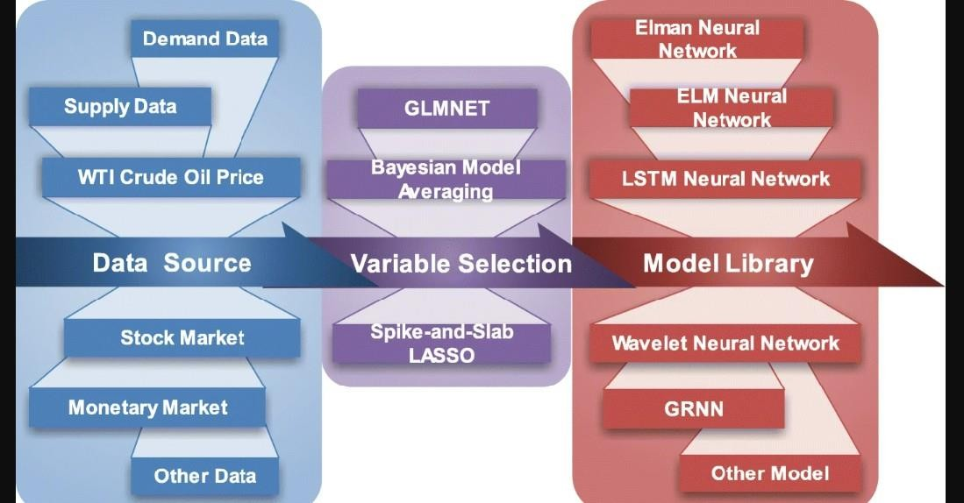

# FIG :1

**NOTE:** The flow chart of variable selection LSTM research framework.

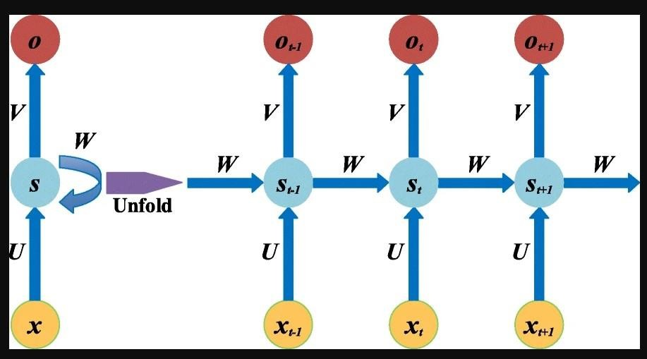

# FIG:2

**NOTE**: An unrolled recurrent neural network.

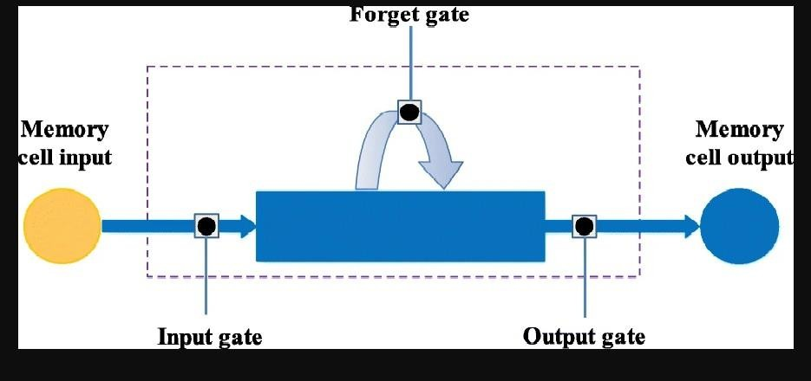

# FIG:3

**NOTE**: The architecture of an LSTM memory cell.

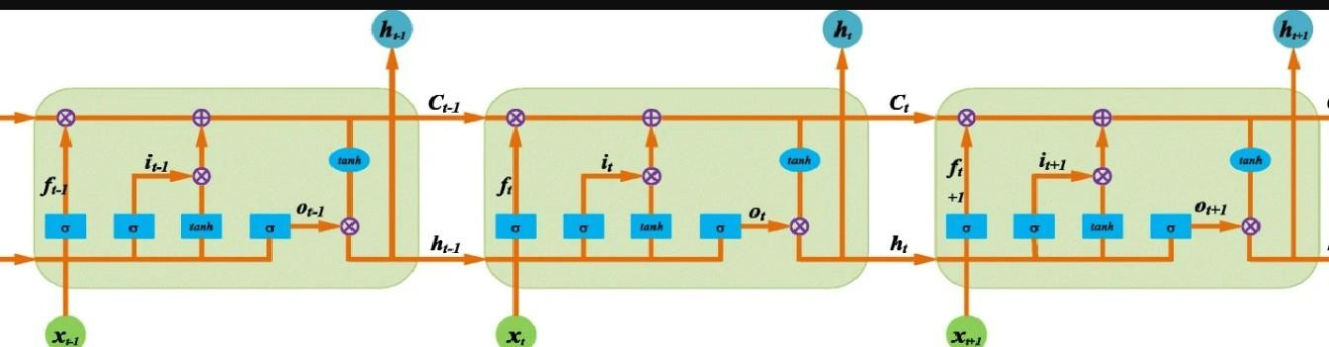

# FIG:4

**NOTE:** The repeating module in an LSTM contains four interacting layers.